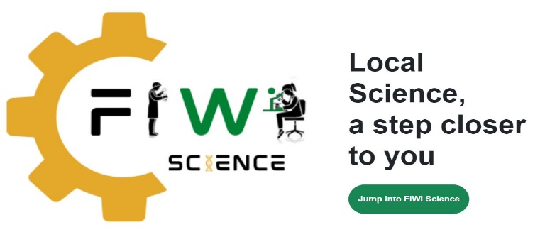

**FREQUENTLY ASKED QUESTIONS**

1. What is STEM ?

ANSWER: Science, Technology, Engineering and Mathematics. STEM Education is an approach to education that should include all these areas but focuses on hands-on and problem-based learning approaches e.g. observation using all the senses and experimentation. It encourages the development of logical and critical thinking skills that are usually associated with the 4 broad subject areas of STEM.

1. What is Science ?

ANSWER: Science according to the Britannica is “any system of knowledge that is concerned with the physical world and its phenomena and that entails unbiased observations and systematic experimentation”. This approach to knowledge (using observations and developing and testing hypotheses) is called the scientific method. The natural sciences e.g. physics, chemistry and biology study the natural world. The formal sciences e.g. mathematics and theoretical computer science are grouped separately as the main systematic approach used is called deductive reasoning. Technology or applied sciences are disciplines that use scientific knowledge for practical purposes e.g. engineering, medicine and environmental management.

1. Who is a scientist ?

ANSWER: Common definitions include the following:-

* A person who conducts research and/or uses research data to advance knowledge and/or technology in an area of the natural sciences – astronomy, physics, chemistry earth sciences (geology/geography) and biology.

The method or approach to conducting research and/or using research data is important and is sometimes referred to as the “scientific method” which has been in use since at least the 17th Century and which focuses on careful observation, asking questions, developing possible explanations to answer the questions (hypothesis) and then testing the hypothesis by experimentation or other means usually involving measurements

One of the main things that identifies a scientist is the way they are trained to think in a very systematic and unbiased way using the scientific method. This means that scientists tend to have very good critical thinking and problem-solving skills that are necessary for sustainable development and which most employers find very useful.

1. What does a scientist do ?

ANSWER: That’s a hard question to answer as there are so many different types of scientists, even within the same general field e.g. chemistry. Some chemists may work in the laboratory of a pharmaceutical industry – ensuring quality of existing medications whilst another might work in the same industry, in research - developing new products or testing products for safety etc. And, not all chemists work in a laboratory – some may work in “the field” i.e. our environment – collecting samples, testing water and air quality etc. Still others may work at a university and do all of these things in addition to teaching.

1. How much will I earn as a scientist ?

ANSWER: Another hard question as it depends on many things:-

1. Government (public sector) staff usually earn less than private sector and the non-government/not-for-profit/charitable sector earns the least.
2. Some organisations have set salary ranges whilst some companies are more flexible and how much you earn may depend on how well you negotiate and how much you earn for the company.
3. Many scientists work outside the science field and surveys in the USA have found that employees with a science degree working in another field e.g. management, are often paid by their non-science degree counter-parts.
4. How much you earn also depends on whether you have an undergraduate or a post-graduate degree and your level of experience, particularly in the same field and the actual job level.
5. One also needs to consider what benefits e.g. pension, health & life insurance, vehicle allowance, uniform allowance, training opportunities and experience etc. may be provided.

Typical salaries ranges in Jamaica are (inclusive taxes – PAYE is about 25% after the tax threshold up to JA$6million and 30% thereafter and NIS, NHT and Education Tax together are about 6.75%):-

|  |  |  |  |
| --- | --- | --- | --- |
|  | **SALARY RANGES FOR SCIENTISTS IN JAMAICA** | | |
|  | **Government** | **UWI** | **Private Sector** |
| Chief Technical Director  (M.Sc. plus experience) | 11.4M to 18.7M  Including benefits |  |  |
| Science & Technology Positions (B.Sc. – Ph.D) | 3.5M to 12.4M including benefits | 2.8M to 14.8 M plus benefits | 1.8M to 22M  Including benefits |

[Monthly-Paid-Scales-2022-2025.pdf](https://www.mof.gov.jm/wp-content/uploads/Monthly-Paid-Scales-2022-2025.pdf)(GOJ Salary Scales 2022 – 2025)

1. Is a degree worth it ?

According to Salary Explorer: <https://www.salaryexplorer.com/:->

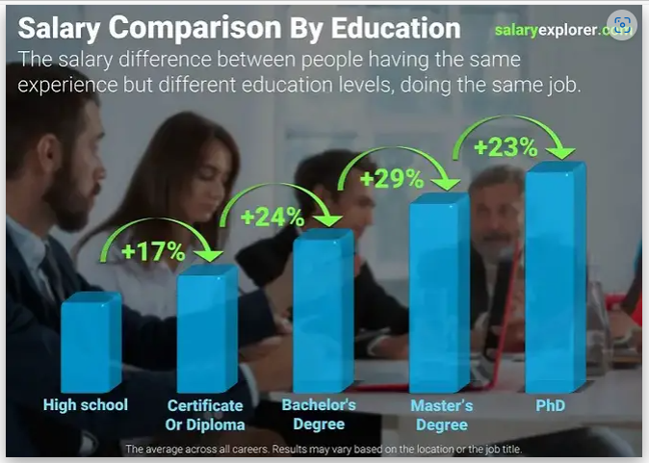

* Our results showed that individuals with a certificate or diploma earned an average of 17% more than those who only completed high school.
* Those who obtained a Bachelor's Degree earned 24% more than their counterparts with a certificate or diploma.
* Professionals with a Master's Degree earned 29% more than those with a Bachelor's Degree.
* Finally, those who held a PhD earned an average of 23% more than those with a Master's Degree while performing the same job.

1. When I finish my undergraduate degree – how do I know I will get a job – what can I do to ensure I get a job ?

ANSWER:-

1. Try to get summer/holiday jobs from as early as you can – the fact is, employers are looking for staff with work experience (not just specific job knowledge) but they want to know that you have experience getting up and going to work every day and getting along with co-workers and being supervised.
2. Don’t be a job snob – any legal work including volunteering is better than no work at all – because it is providing with you with, work experience. Working teaches you many new skills and provides you with new knowledge, it also provides opportunities for networking – meeting and interacting with people who may have a positive influence on your life. As long as the costs of getting to work are covered – it is better to take a job and get started on developing your CV.
3. Be realistic - Big money, fancy car and house don’t come with your first – you have to work for those and you need to start saving early – most people don’t get those things until mid-life.
4. Make sure your CV is easy to read – clear, concise, with no gaps – get someone to review it for you and ensure you include all your work experience including volunteering – and indicate what you accomplished and what skills you acquired - not just the job title.
5. Practice good interview skills.
6. Be persistent – you may have to send out hundreds of applications before you get an interview and unfortunately, most companies don’t respond unless you have been short-listed. It can be frustrating and depressing – but that’s why it’s good to have something else to do that will provide you with work experience in the mean-time.